Wireframe Document

Financial Analytics

Revision Number: 1.0

Last Date of Revision**:**

**Rohan Bagde**

Homepage

As per the problem statement:

Main Dashboard

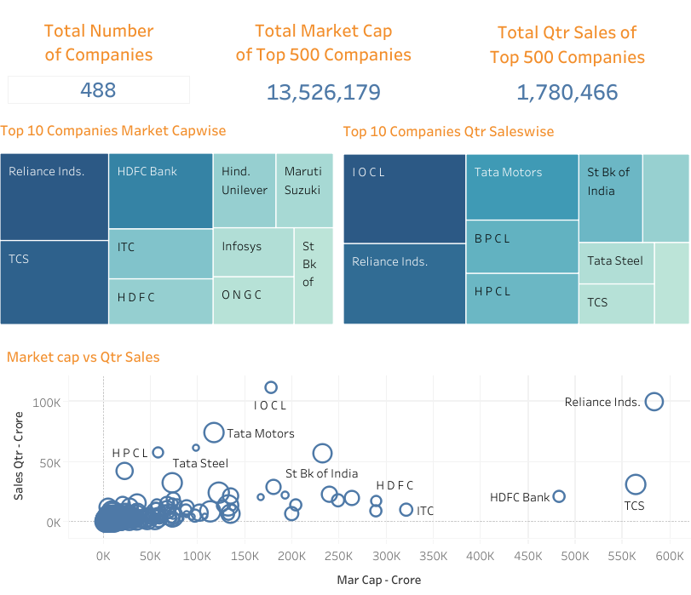

Top 10 Companies Market Cap wise

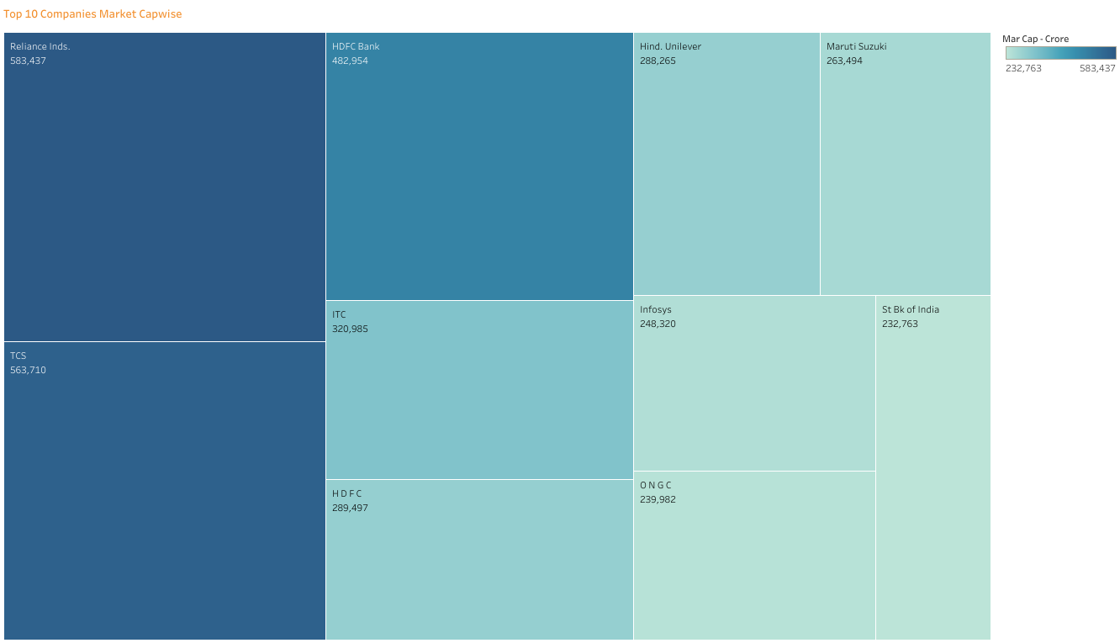

Top 10 Companies Sales wise

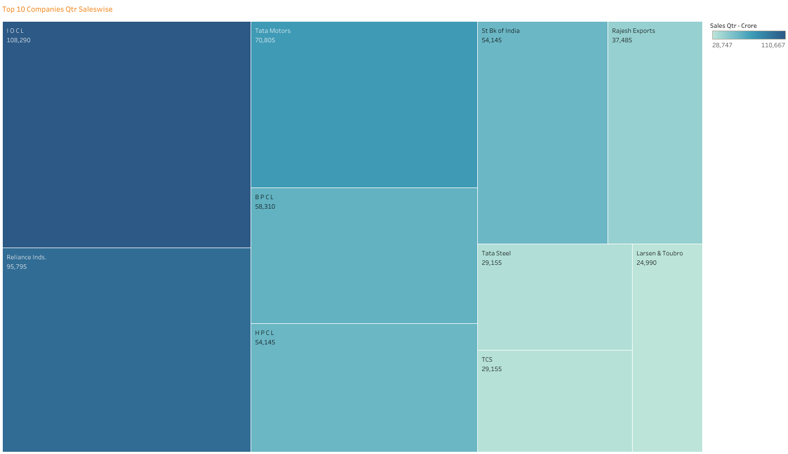

Relation between Companies Sales and Market Cap

